Accidents Worksheet
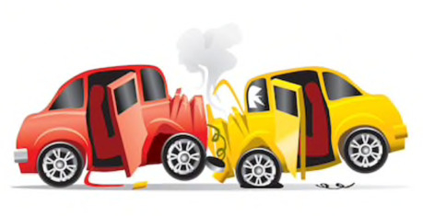

- When performing CPR, I should do _____compressions per minute. That is _____every second. I’ll press down about _____ cm.

- The part of the body I’ll press is centre of the ________________________________

- DR ABC stands for ______________________________________________________

_____________________________________________________________________

- I’d place a Warning Triangle _______ metres away.

- If I’m involved in an accident but I can’t let anyone know at the time, I’ll report to the ____________________within _______ hours

- The police want to see these documents:

______________________________________________________________________

- If I break down on a level crossing, the first thing I’ll do is tell drivers behind / leave the vehicle and get everyone clear (circle the correct answer)

- Before driving through a tunnel, I need to turn my _______________ on, take my ______________________________off. I also need to turn my _______________on so I can listen for updates.

- If I break down in a tunnel, I’ll put my _______________________ on and call for help.

- If my car is on fire in a tunnel, I’ll get out of my car / drive out of the tunnel, if it’s safe. (circle the correct answer)

- A motorcyclist has been in an accident and is lying in the road. You are the first to arrive:

- Would you remove his helmet?

- Would you try to move the motorcyclist?

- He’s bleeding heavily from a wound on his leg. What can you do to help?

