Accidents Worksheet
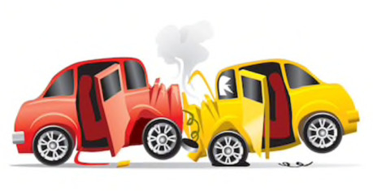

- When performing CPR, I should do _______compressions per minute.
That is ________every second.

- When performing CPR, I’ll press down about ________ cm.

- The part of the body I’ll press is centre of the ________________________________

- DR ABC stands for ______________________________________________________

- DR ABC is a way to remember what you need to do when ______________________

_____________________________________________________________________

